***1. The Whole Weighted Co-Membership Network***

* Each group has its TOP 100 weighted edges
* Nodes: 3226
* Edges: 106036
* The size of each node is based on the **degree**
* Different colors of nodes refer to its modularity class (community)

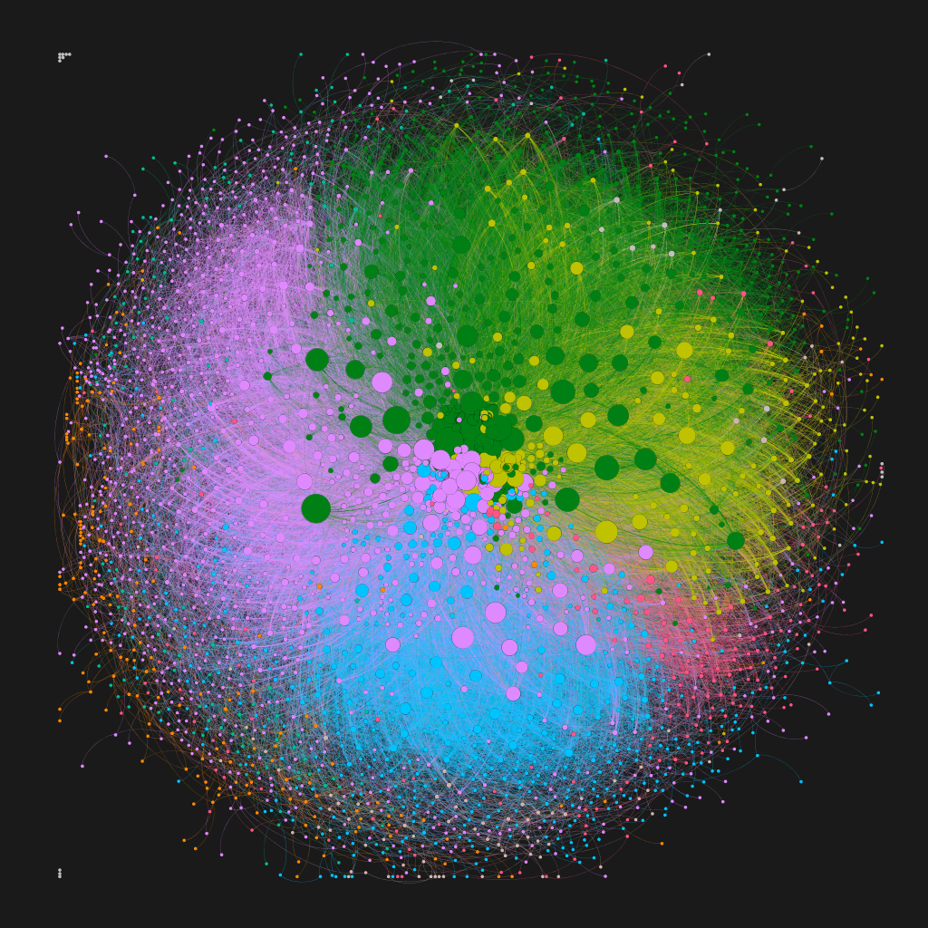

***1.1 Sub Networks in terms of Avg Degree***

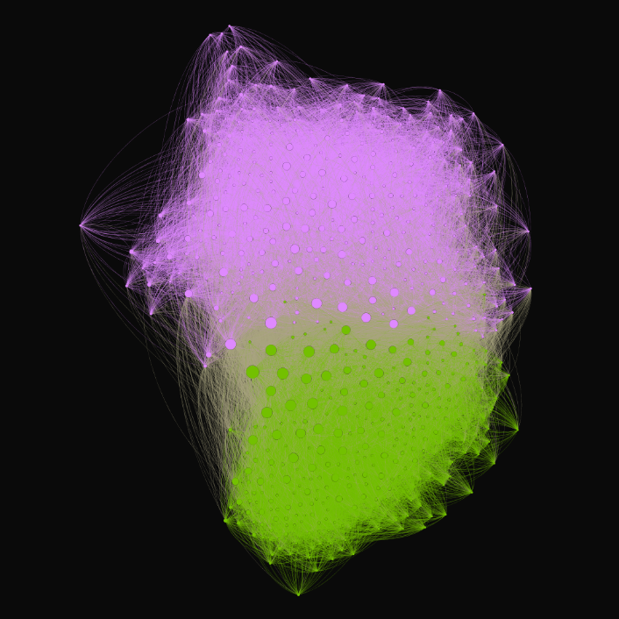

a. Below Avg Degree b. Above Avg Degree

***1.2 Communities***

***1.3 Top 10% Weighted Edges***

***2. The Whole Weighted Co-Membership Network***

* Each group has its TOP 100 weighted edges
* Nodes: 3226
* Edges: 106036
* The size of each node is based on the **size of member counts**
* Different colors of nodes refer to its modularity class (community)

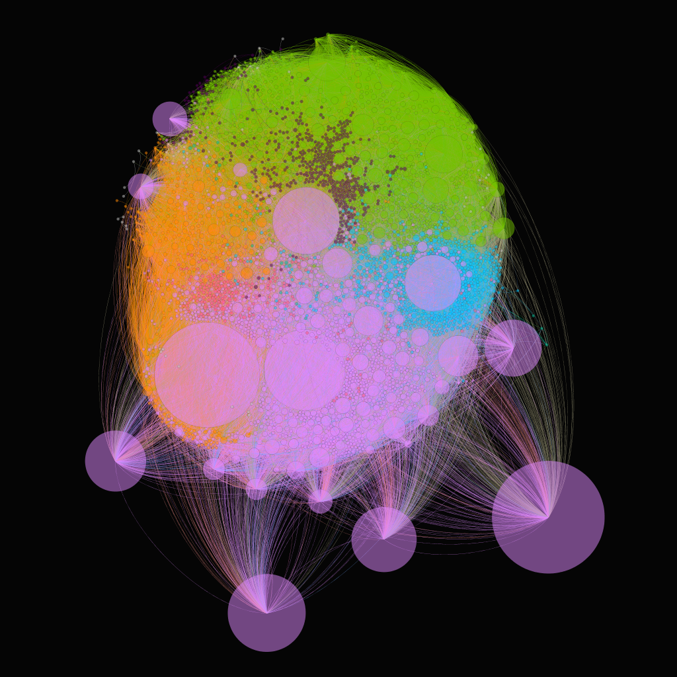

***2.1 Sub Networks in terms of Size of member counts***

a. Extra Large Groups b. Large Groups c. Medium Groups

***2.2 The Whole Networks Without Edges***

a. Size based on Member count b. Size based on Photo per Member c. Size based on Group pool